Kmeans

1. Giới thiệu

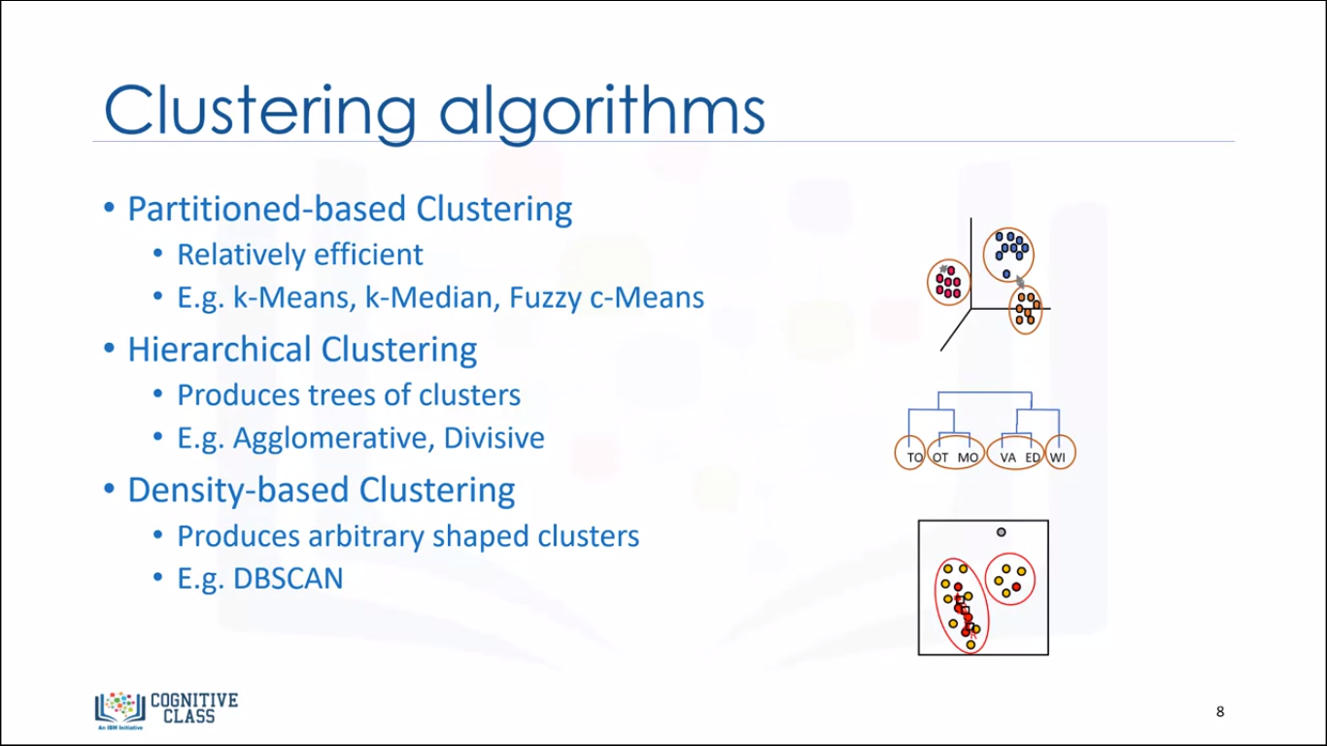

1. Mục tiêu của Kmeans

What is the objective of k-means?

* To form clusters in such a way that similar samples go into a cluster, and dissimilar samples fall into different clusters.
* To minimize the “intra cluster” distances and maximize the “inter-cluster” distances.
* To divide the data into non-overlapping clusters without any cluster-internal structure